REQUIRED TEXTS: Students will need to purchase two novels for the class. Students must have these books in order to facilitate annotations. Please ensure that you have purchased the correct edition (check the ISBN number or follow the links provided) so that you are on the same page as your peers and instructor.
The Great Gatsby by F. Scott Fitzgerald | ISBN-13: 9780743273565 | https://www.amazon.com/Great-Gatsby-F-Scott-Fitzgerald/dp/0743273567/ref=sr_1_3?s=books&ie=UTF8&qid=1528464024&sr=1-3&keywords=the+great+gatsby
Slaughterhouse-Five by Kurt Vonnegut | - ISBN-13: 978-0812988529 | https://www.amazon.com/Slaughterhouse-Five-Novel-Modern-Library-Novels/dp/0385333846/ref=sr_1_1?s=books&ie=UTF8&qid=1528463840&sr=1-1&keywords=slaughterhouse+five

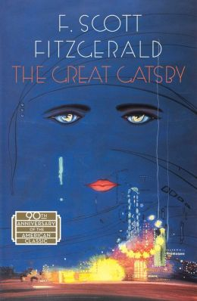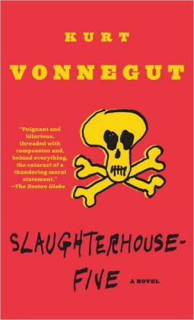

OPTIONAL TEXT: Students are encouraged to purchase a copy of the textbook we use in class. Ardrey Kell, unfortunately, does not have enough editions of this textbook for every Lang student.
Language of Composition  NOTE: Both Amazon and Chegg Books (you’ll become very familiar with this site in college) have an option to rent the textbook. I am not sure how this works, but it seems like a viable option. | ISBN-13: 978-0312676506  ISBN-10: 0312676506 | https://www.amazon.com/Language-Composition-Reading-Writing-Rhetoric/dp/0312676506/ref=sr_1_1?s=books&ie=UTF8&qid=1528463273&sr=1-1&keywords=language+of+composition  https://www.chegg.com/textbooks/the-language-of-composition-2nd-edition-9780312676506-0312676506?trackid=3fd7f9a5&strackid=612ef81f&ii=1

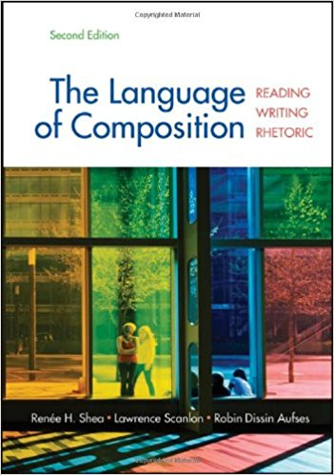
SUPPLEMENTAL TEXTS: These are not books we will use in class, but they are certainly helpful. Beside the title of each text is a brief description of the text and how students can benefit from purchasing it.
Five Steps to Five: AP Language and Composition | A practice book full of test strategies and test items. Extra practice has never hurt in preparing for the difficult AP exam in May. | https://www.amazon.com/Steps-AP-English-Language-2018/dp/1259862313/ref=sr_1_1?s=books&ie=UTF8&qid=1528465718&sr=1-1&keywords=five+steps+to+a+five+ap+english+language
The Elements of Style by Strunk and White | A concise, easy-to-read grammar book. You don’t understand grammar; I understand that. This book will help you understand it better. An updated “simplified and illustrated” version has recently been published. I can’t comment on it (I have never read it), but it’s Elements of Style. It can’t be bad. | Traditional version:  https://www.amazon.com/Elements-Style-Fourth-William-Strunk/dp/020530902X/ref=sr_1_3?s=books&ie=UTF8&qid=1528465855&sr=1-3&keywords=elements+of+style  Illustrated version:  https://www.amazon.com/Elements-Style-Simplified-Illustrated-People-ebook/dp/B079M1692M/ref=sr_1_1_sspa?s=books&ie=UTF8&qid=1528465855&sr=1-1-spons&keywords=elements+of+style&psc=1
Thank you for Arguing by Jay Heinrichs | Heinrichs’ simple, everyday language helps make this book enjoyable. It is a tidy summary of rhetoric and its applications. Highly recommended. | https://www.amazon.com/Thank-You-Arguing-Third-Persuasion/dp/0804189935/ref=sr_1_1?s=books&ie=UTF8&qid=1528466053&sr=1-1&keywords=thank+you+for+arguing

